Flipkart Sales Insights and Analysis Dashboard

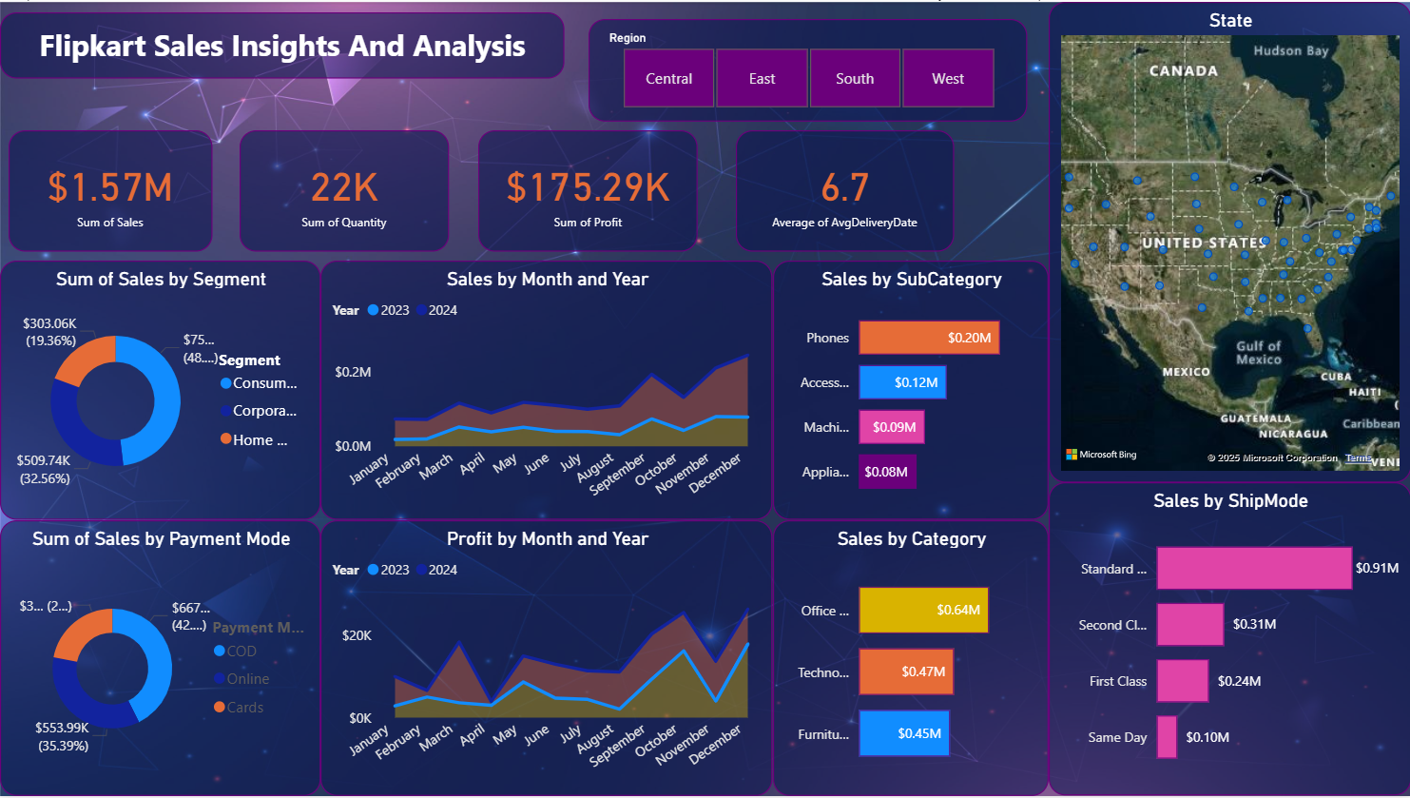

**Overview**

This Power BI dashboard provides a comprehensive analysis of Flipkart's sales data across various dimensions such as time, geography, customer segments, product categories, and shipping modes. The insights derived help in making data-driven decisions to optimize performance and improve customer satisfaction.

**🎯 Objective**

* To analyze sales performance and customer behavior.
* To identify profitable segments, regions, and categories.
* To monitor delivery performance and optimize logistics.
* To support strategic decision-making with visual insights.

**📁 Data Sources**

The dashboard uses preprocessed e-commerce transactional data with the following key tables:

* Orders
* Customers
* Products
* Categories
* Regions
* Delivery Details

**📌 Key KPIs Displayed**

| **KPI** | **Value** | **Description** |
| --- | --- | --- |
| 💰 **Sum of Sales** | $1.57M | Total revenue generated |
| 📦 **Sum of Quantity** | 22K | Total items sold |
| 🏆 **Sum of Profit** | $175.29K | Total profit earned |
| ⏱ **Avg Delivery Days** | 6.7 days | Average time taken for delivery |

**📈 Visuals and Insights**

**1. Sales by Segment (Donut Chart)**

* **Segments:** Consumer, Corporate, Home Office
* **Insight:** Consumer segment contributes the highest with ~32.56% of total sales.

**2. Sales by Month and Year (Line Chart)**

* **Years:** 2023 vs 2024
* **Insight:** Seasonal trends show peaks in November and December, indicating festive season impact.

**3. Sales by Sub-Category (Bar Chart)**

* **Top Products:** Phones, Accessories, Machines
* **Insight:** Phones are the highest-selling sub-category with $0.20M in sales.

**4. Sales by Payment Mode (Donut Chart)**

* **Modes:** Online, COD, Cards
* **Insight:** Online payments dominate with 35.39% share.

**5. Profit by Month and Year (Line Chart)**

* **Insight:** Profit trends align with sales, with noticeable spikes in year-end months.

**6. Sales by Category (Bar Chart)**

* **Categories:** Office Supplies, Technology, Furniture
* **Insight:** Office Supplies top the list with $0.64M in sales.

**7. Sales by Ship Mode (Bar Chart)**

* **Modes:** Standard Class, Second Class, First Class, Same Day
* **Insight:** Standard Class shipping is the most preferred mode ($0.91M sales).

**8. Geographical Sales Map**

* **Map View:** Sales spread across U.S. states
* **Insight:** High concentration of sales in southern and eastern states.

**🌍 Filters & Interactivity**

* **Region Filter:** Central, East, South, West
* Allows users to dynamically analyze KPIs and charts based on selected region.
* Focus marketing efforts on consumer segments for higher returns.
* Optimize logistics and shipping for the Standard Class mode.
* Inventory planning should prioritize phones and accessories.
* Continue promotional campaigns in Q4 to leverage festive spikes.

**🧱 Technology Used**

* **Tool:** Microsoft Power BI
* **Data Preparation:** Power Query & DAX
* **Visualization Types:** Donut charts, Bar charts, Line graphs, Maps

**📌 Future Scope**

* Integrate real-time data updates.
* Add forecasting models for sales/profit trends.
* Incorporate customer feedback and sentiment analysis.